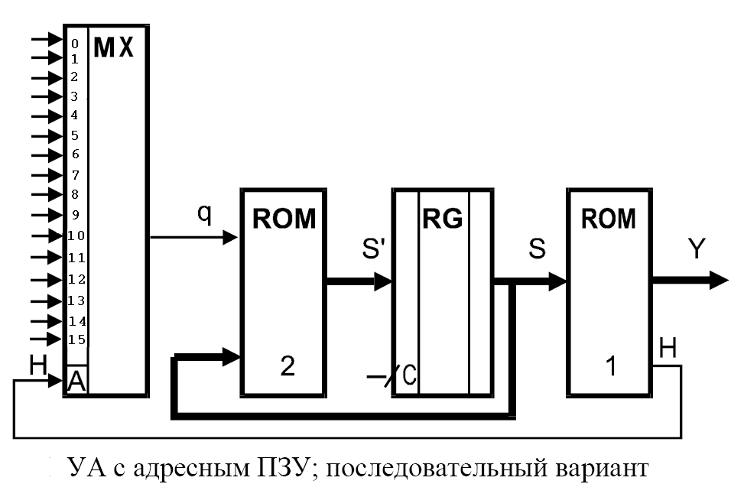

Признаки:

Ri – 0
S – 1
In[22] – 2
E1 – 3
PB0 or ¬P[30] – 4
PB0 – 5
zB – 6
G – 7
B0 – 8
L – 9
A0 – 10
zA – 11
B[31] – 12
A[23] – 13
A[22] – 14
E2 – 15

